CO CURRICULAR ACTIVITIES BY DEPARTMENT 2020 – 2021

To commemorate the World Aids Day 2021 the Department of Social Work organized Poster making Competition on the Theme – Health Appropriate Behavior on 4th December 2021

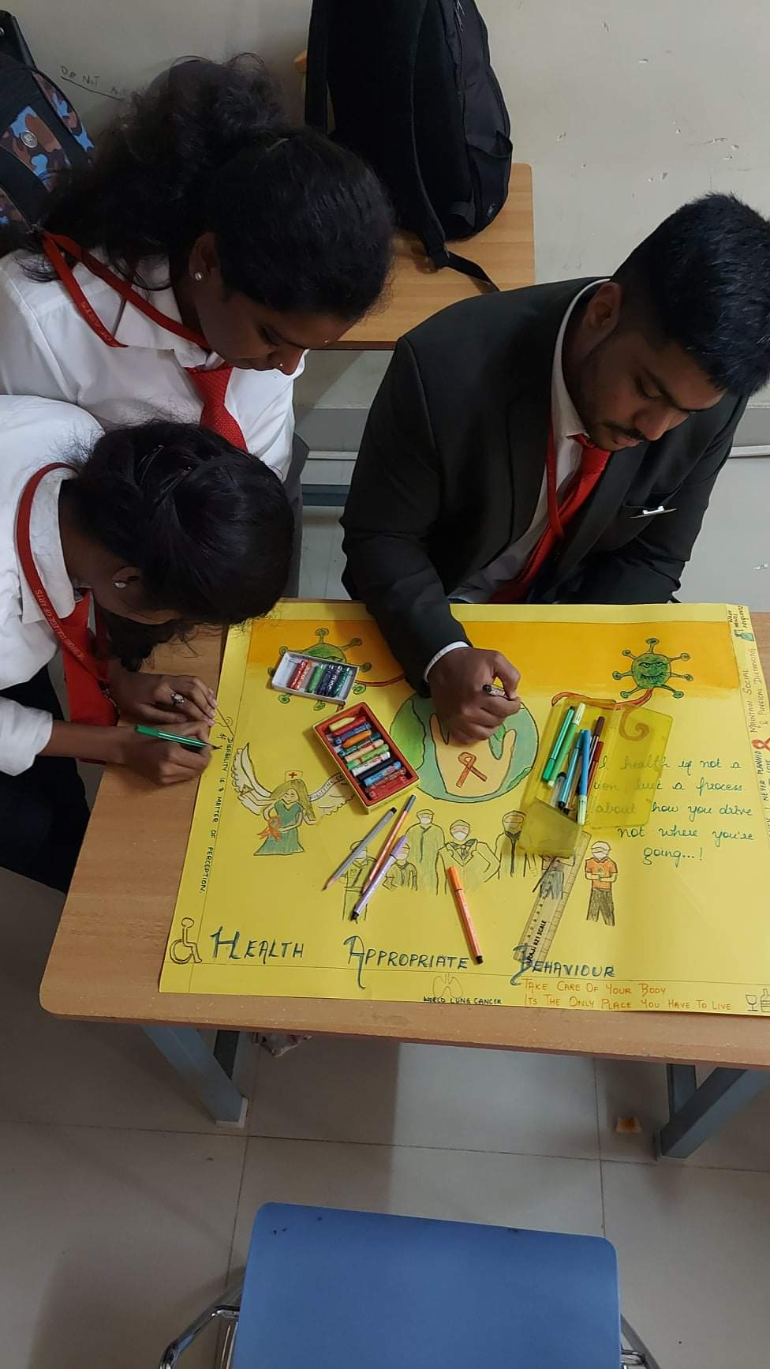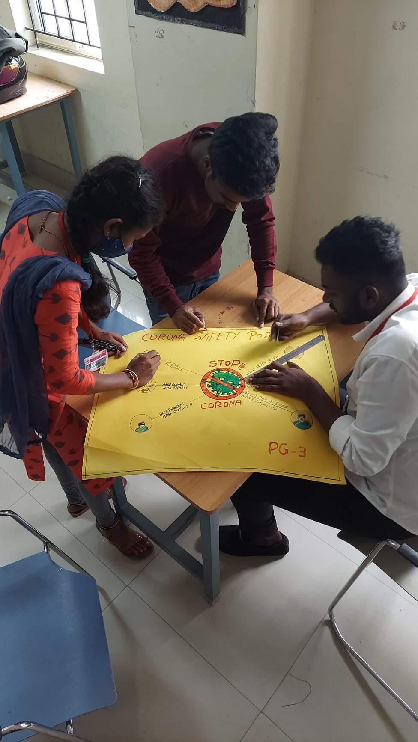

To commemorate the World Aids Day 2021 the Department of Social Work held the Red Ribbon Campaign on 1st December 2021

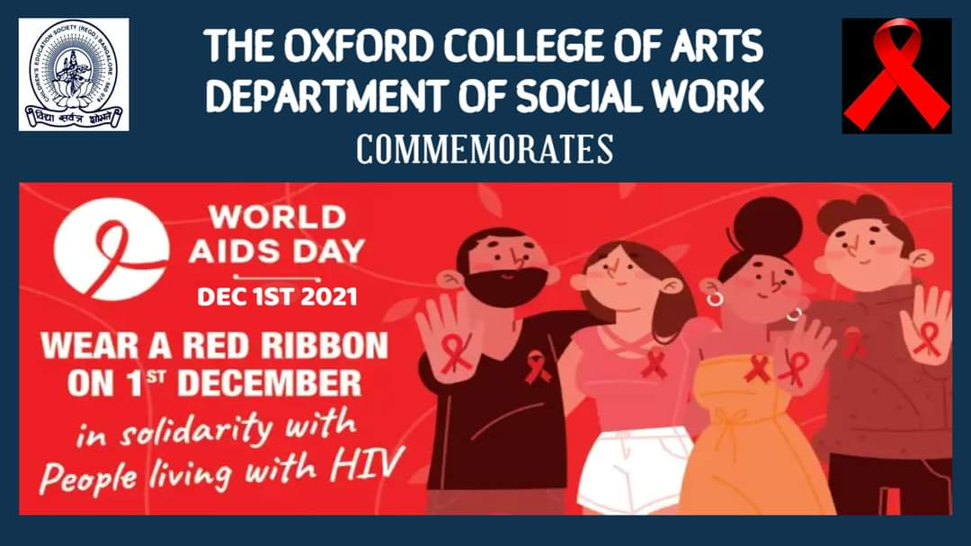

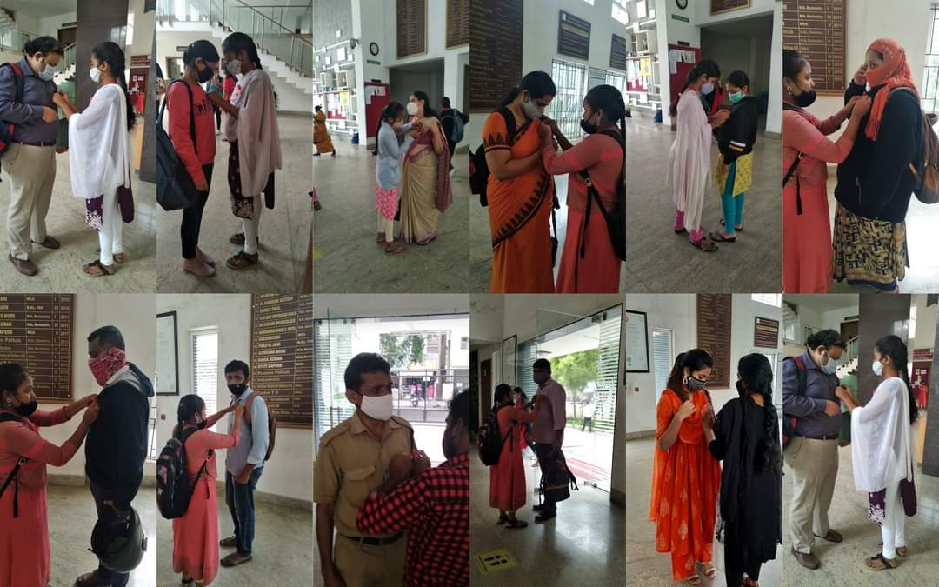

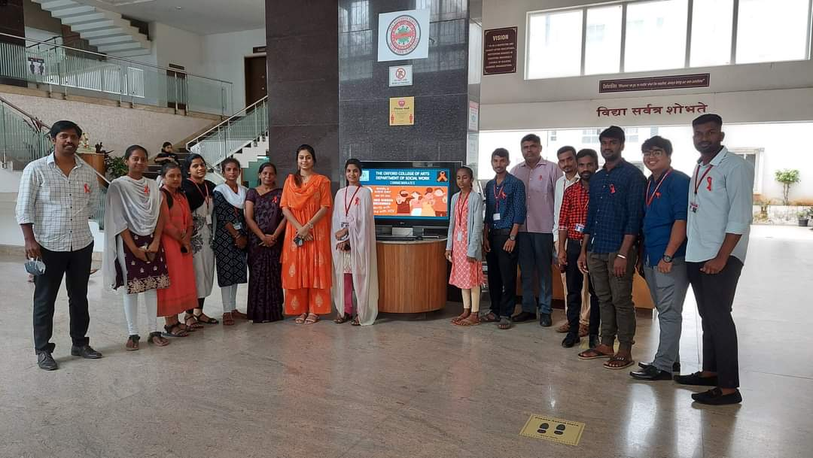

To commemorate the World Social Work Day 2021, the Department of Social Work held the debate on the theme: Should the marriage age of women be increased?
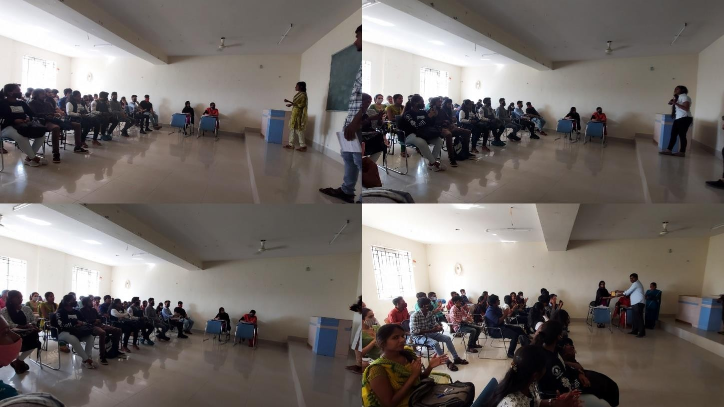

To commemorate the World Social Work Day 2021, the Department of Social Work has organized The Poster Presentation on the theme: Social Solidarity during Pandemic.
